Assignment: Business Process Modeling Fundamentals (20 points)
Name: Mayukh Tatipamula Score:
Consider the following scenario:
You have recently been hired as a process engineer at an office furniture company. It’s a small firm that’s looking to expand. The prices of raw materials such as hardwoods, fabrics and such are constantly changing. Customers view furniture in your company’s showroom and consult a catalog for furniture details. Prices are not listed, so when the customer asks about the price of a piece of furniture in the collection, the sales representative must consult a manual price sheet. If the prices are more than a day old, then they call the material supplier for the most recent price. Note that a number of sales have been lost because of unexpected price increases because the salesperson gives an outdated price to the customer. The supplier checks prices using an information system that tracks market and commodity prices of materials and provides your company’s salesperson with the updated price. Once the salesperson obtains pricing, they update their manual price sheet and provide the customer with the price. The customer then decides whether to purchase the piece. If the customer chooses to purchase, the sales rep will ask finance to run a credit check on the customer. Your company has a very small finance department, so sometimes credit checks are delayed, causing some customers to abandon their purchases. Finance determines whether the customer is creditworthy or not. If not, finance advises sales, who advises the customer, and the transaction ends. If the customer is creditworthy, the transaction proceeds, the customer pays and the transaction ends with the customer receiving a receipt.
Assess the business impact of the situation and model the process “as is.” Next, determine where in the process information systems make the “Furniture Purchase” process more efficient. Ask yourself where you can eliminate tasks, repositories, and even entire roles? Then model your improved process that streamlines the customer’s experience and ensures always updated pricing.
Please ensure the Word document is named using the following pattern: Section-First Initial Last Name-BPM.docx; e.g., 501 JYoung BPM.docx. Please ensure the email subject line is the same as the Word document name. Do not send links to Word documents. Failure to follow these instructions will result in a zero per the syllabus. Do not use any online sources to complete the BPM and value chain other than those specifically authorized by the instructor. This is an individual assignment; do not work with others on the assignment.
- List two metrics that measure operational efficiency. (2 pts)
1. Cycle time - Knowledge Management is an excellent ITIL process for improving cycling time. It enhances access to accurate, real-time pricing, customer credit insights, and transparent decision-making guidelines. By centralizing and organizing essential information, Knowledge Management ensures that employees can retrieve the correct data at the right time without relying on slow, manual methods. This leads to faster completion of key tasks such as verifying prices and performing credit checks, which are critical in furniture purchases. As a result, cycling time is significantly reduced, allowing transactions to flow more smoothly and efficiently.
2. First-Time Accuracy - First-Time Accuracy is critical to ensuring that processes are completed correctly the first time without requiring rework or corrections. While Knowledge Management supports this by providing accurate information, another highly effective ITIL process that reinforces first-time accuracy is Service Validation and Testing. This process ensures that new services, updates, or system integrations, such as real-time pricing tools or automated credit checks, are thoroughly tested before being deployed into the live environment. By validating that everything functions as expected, Service Validation and Testing significantly reduce the risk of errors that often occur in manual tasks. This proactive approach helps prevent delays and breakdowns caused by system failures or misconfigured features. As a result, it enhances operational efficiency and maintains a smoother, more reliable customer experience.

- Diagram existing process. Using Lucidchart, model the existing process; insert your diagram here. (9 pts)
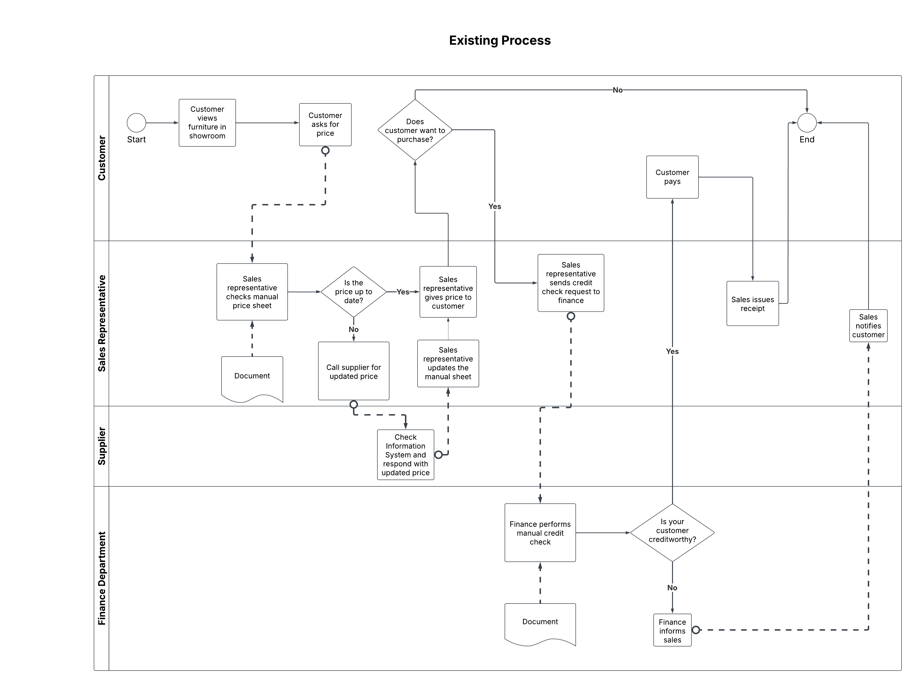

- Diagram the improved process. Using Lucidchart, model the improved process; insert your diagram here. (9 pts)
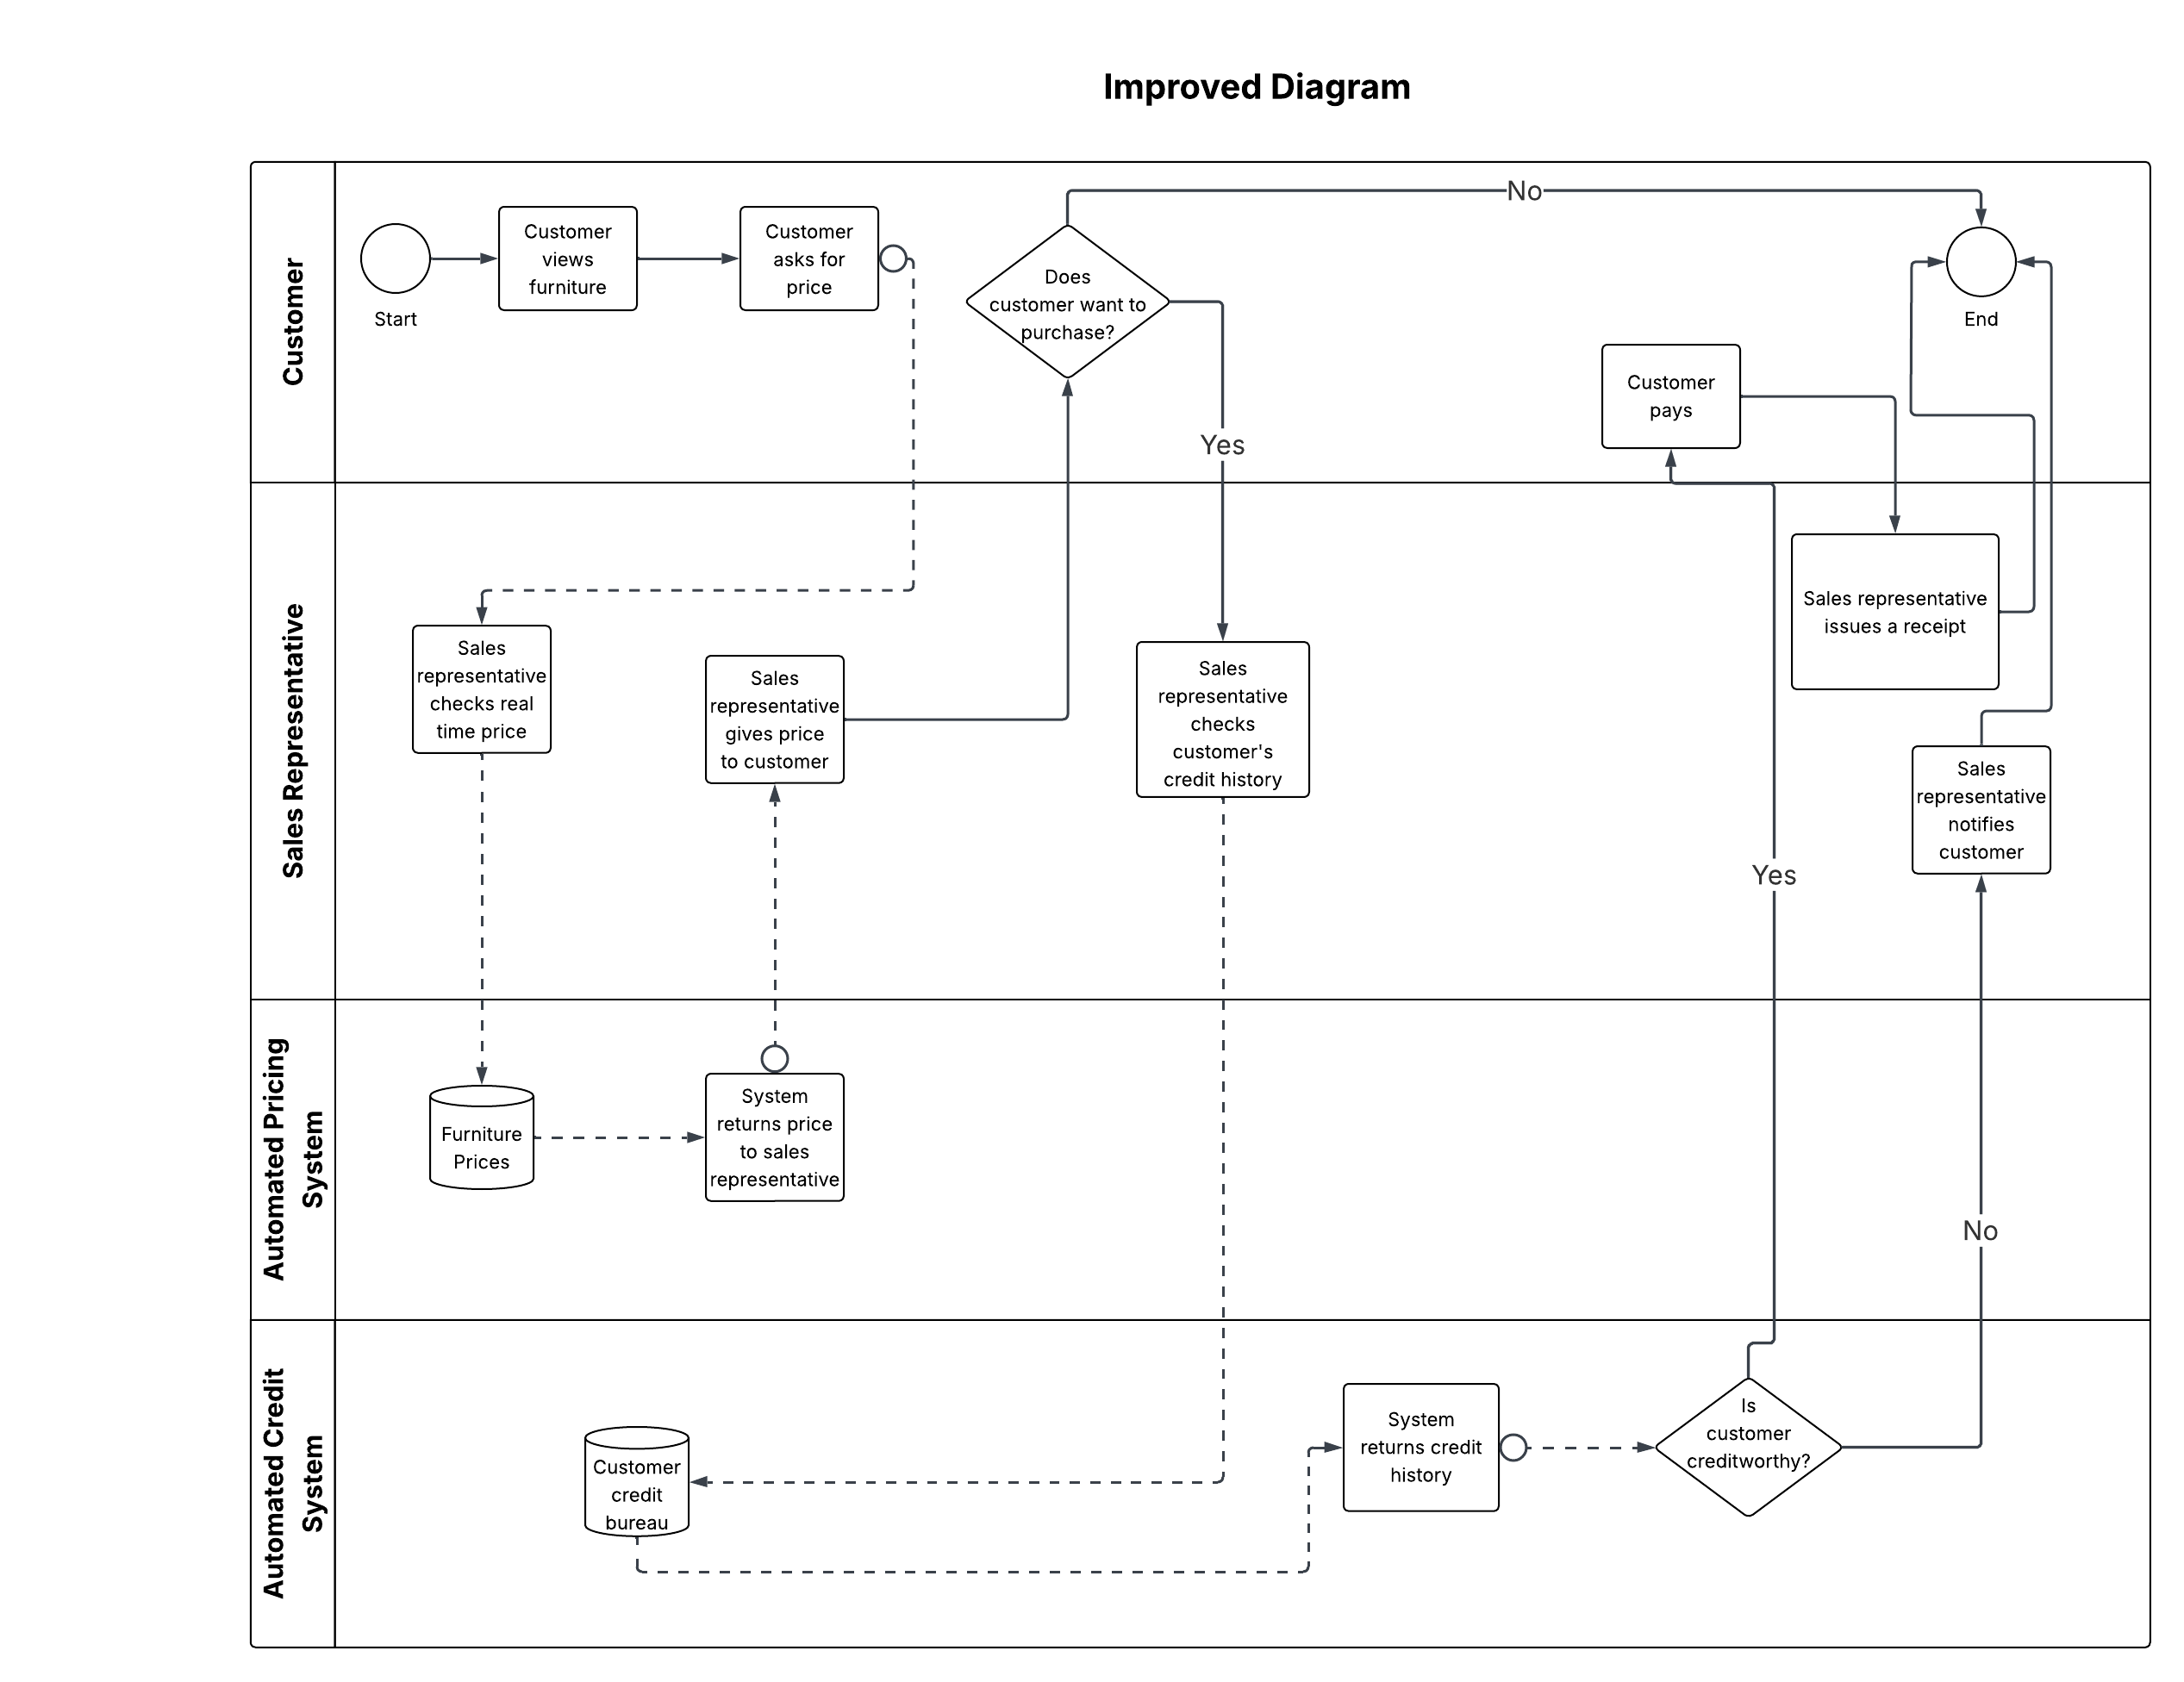

Value Chain. Using Lucidchart, model your company’s value chain; insert your diagram here. (2 pts)

